Week 1 Problem 1.16
Use the construction given in Theorem 1.39 to convert the following two nondeterministic finite automata to equivalent deterministic finite automata.

a
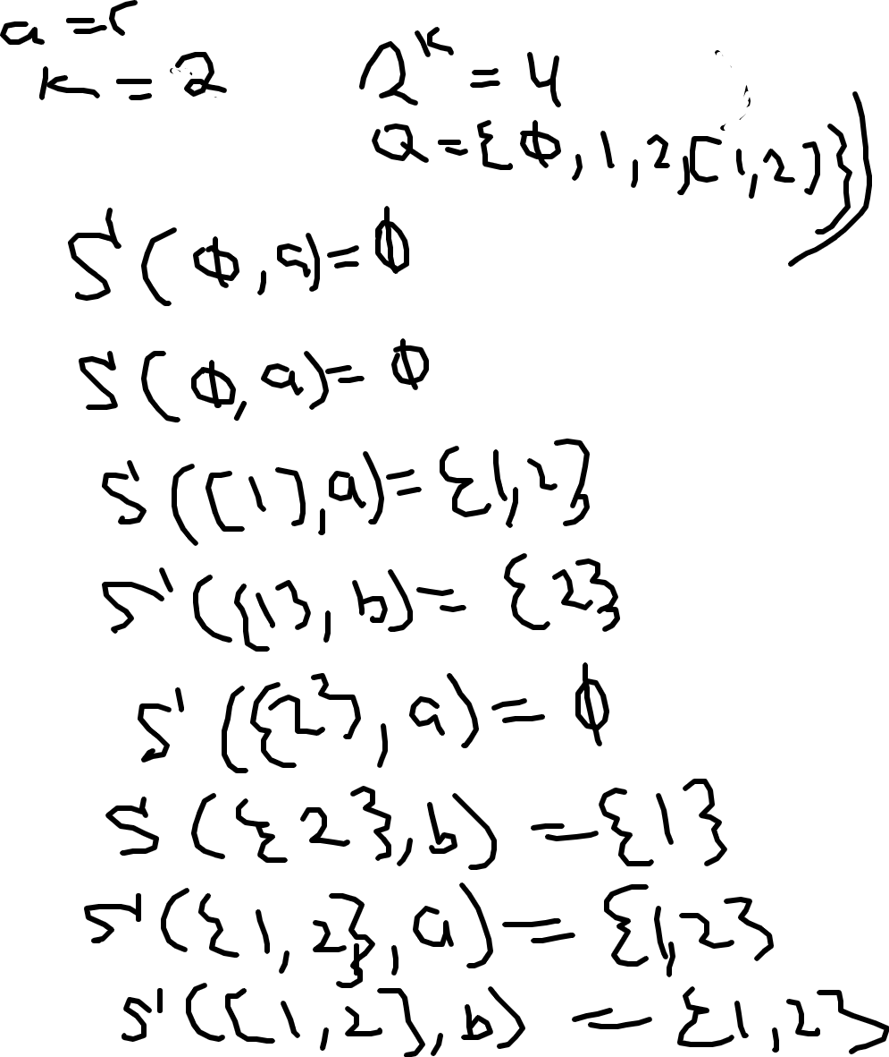
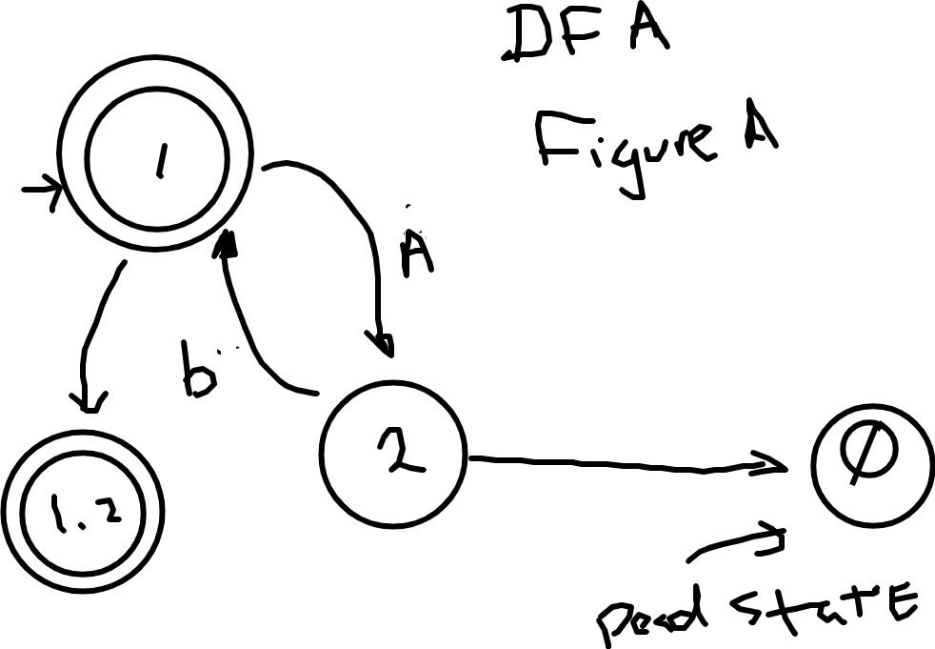

B



